Feature Specification
Nupack System
Anh Nguyen
March 10, 2017

- Assumptions
- There is only one product for each time doing packing service and calculation final price.
- The percentages of flat markup, materials markup, and each person that needs to work on the job could be changed depending on the demand of end users.
- The type of currency could be changed corresponding to the location of the end users which is defined by the country and the spoken language
- There could be sub types of material types (pharmaceuticals, food, electronics). Examples: drugs is one sub types of pharmaceuticals, cooker is one sub type of electronics
- The end user could input the base price with these formats of currency: $12,012.23 or 12012.23 or 12,01223 and expects the output of final price as $12,012.23
- Design
- Class Diagram
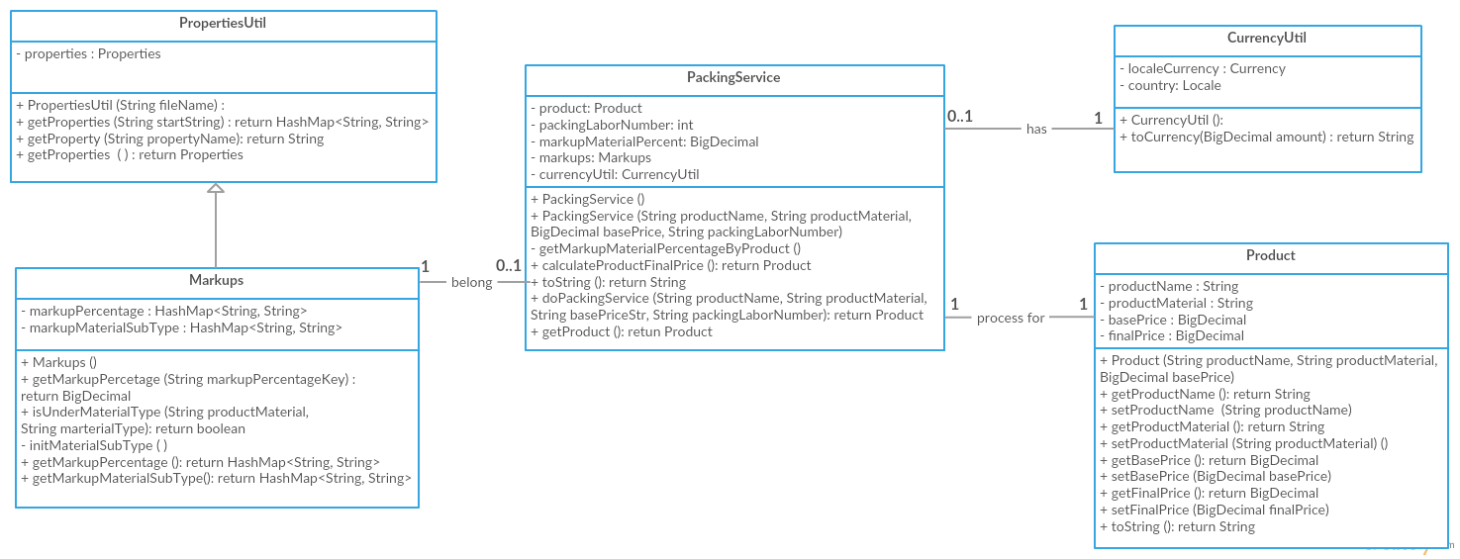
Figure 1: Class Diagram
- Class Description
PropertiesUtil | This class is used to get all properties from the properties file (services.properties). The services.properties will follow the format:  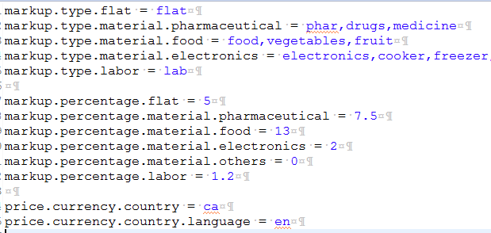  The user can specify the System property(user.path) to the directory path where stores his/her services.properties.  The user can change the percentages of each markup type and sub types of material group (pharmaceutical, food, electronics) and the currency type base on the local country code(defined in ISO 3166) and spoken language code (defined in ISO 639).
Markups  (inherit from PropertiesUtil) | This class is used to store all properties related to Markup with 2 fields:  markupPercentage: HashMap<String1, String2>(String1 is properties key starts with “markup.percentage”, String2 is properties value (Markup percentages) of the coresspoding properties key).Ex: “markup.percentage.flat”, ”5”.  markupMaterialSubType: HashMap<String1, String2>(String1 is a subtype of a product material type(defined in value split by comma of property key starts with “markup.type.material”), String2 is the product material type this sub type belongs to ) Ex: “drugs”, “markup.type.material.pharmaceutical”.
CurrencyUtil | This class is used to convert the BigDecimal number to currency corresponding to the currency code user input in service properties file.  Eg: For Canada dollars: price.currency.country = ca, price.currency.country.language = en
Product | This class is used to store and get all information about Product (Product name, Base Price of Product, Material of Product and Final Price).
PackingService | This class is used to get the information of the base product and the number of people on the packing job, calculate final price of the product and output the packed product information.

- Alternative Design
- Assumptions
- The next improvement of the calculation system could be the packing service will be used for processing multiple products at one time. It may lead to next following class diagram design
Class Diagram
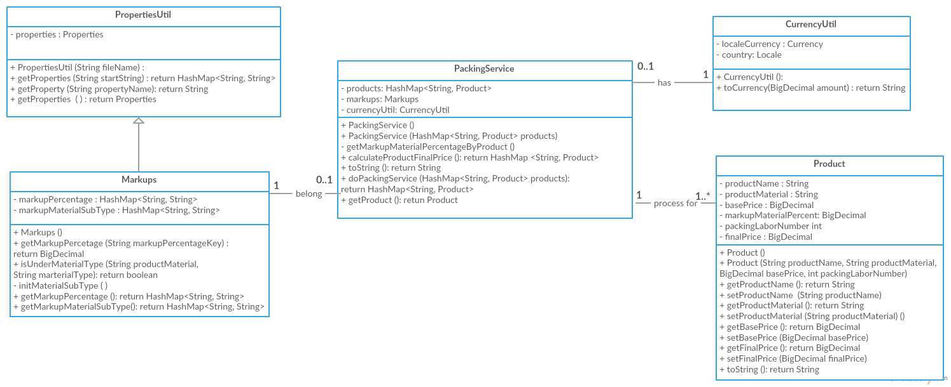
Figure 2: Alternative Class Diagram
- Class Description
PropertiesUtil | The same as above actual design
Markups  (inherit from PropertiesUtil) | The same as above actual design
CurrencyUtil | The same as above actual design
Product | This class will be extended with the field packingLaborNumber specifying the number of working people on this product and markupMaterialPercent specifying the markup percent base on this product material
PackingService | This class will be change a Product field to a HashMap<String, Product> which will be a list of products on the packing process and remove the fields packingLaborNumber and markupMaterialPercent

